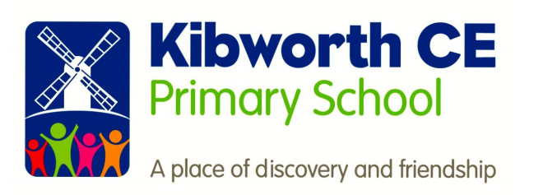

**Reading**

**Subject Policy**

|  |  |  |  |
| --- | --- | --- | --- |
| **This policy was approved as follows:** | | | |
| **Adopted by:** | **J Cornish** | **Date:** | September 2019 |
| **Review Date:** |  | **Review frequency:** | 3 yearly |
|  | | | |

**Rationale**

**The Importance of Reading**

At Kibworth, we believe that reading is at the heart of everything we do and is an essential life skill that provides access to a wealth of opportunities and opens the door to a rich and broad curriculum. It is vital that children acquire good reading skills in order to access the information that will support their learning in all areas. We achieve this through the high quality teaching of reading to secure fluency and a good level of comprehension. This, underpinned by a culture that promotes a love of reading, ensures that our children become articulate and literate individuals who have a positive attitude towards reading.

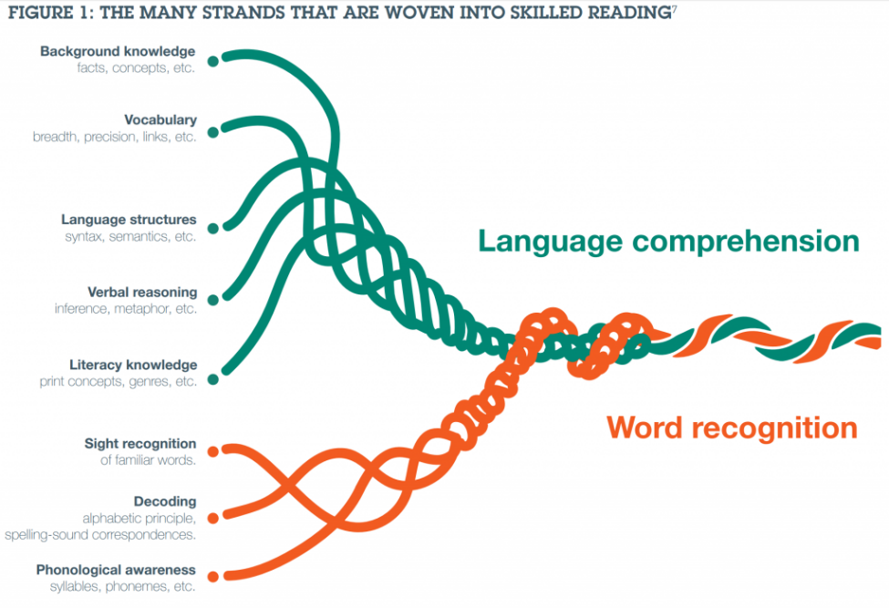At Kibworth, we aim to meet the expectations of ‘Scarborough’s Reading Rope’ which shows how the key strands of language comprehension and word recognition weave together to develop competent readers.

**Intent**

Our intent at Kibworth CE Primary School is to ensure our pupils are **fluent and effective readers** who have a rich vocabulary and enjoy reading for pleasure. We aim:

* To instil a love of reading in children that lasts a lifetime to develop ‘lifelong readers’.
* To develop children’s confidence, fluency and independence to read for different purposes.
* To develop a range of reading strategies that allow children to tackle reading problems and the wider curriculum with confidence.

**Let your light shine in reading**

Through the teaching of reading at Kibworth Primary school, we aim to ensure the children are equipped to deal with the demands of the 21st century and become lifelong learners.

* For children to be exposed to a wide variety of high quality texts through independent reading and story time
* Children will become skilled readers through developing a love of reading.
* Children’s engagement in reading at home will be celebrated through a weekly reading raffle.

**Implementation**

**Teaching of reading**

The school identify that children must *learn to read* before they can *read to learn*. Appropriate teaching strategies are employed through the three areas of reading development:

1. Early reading and phonics
2. Fluency
3. Comprehension
4. **Early reading and phonics (Learning to read)**

The Rose Report (2006) emphasises high quality phonics as a fundamental part of the decoding skills required by children when learning to read.

At Kibworth, we have a consistent, high quality approach to the teaching of phonics across the Early Years Foundation Stage, Key Stage One and on into Key Stage Two for children who still need further support.

**Our primary aims are:**

* *To develop phonetic skills which lead to blending and fluency*
* *To teach children aural discrimination, phonetic awareness and rhyme to aid reading, writing and spelling development*
* *To encourage the use of segmenting and blending skills*
* *To ensure the teaching of phonics is lively, interactive and investigative*
* *To enable children to use phonetic awareness across the curriculum*
* *To ensure that children know the 44 phonemes within the English language*
* *To teach children to recognise the graphemes within words and associate them with the appropriate phoneme when reading*
* *To provide children with strategies to identify and decode ‘tricky words’*
* *To promote confidence and positive attitudes to reading*
* *To promote and encourage good home/school links using a wide range of literature*

**Objectives:**

* *To provide consistent, high quality phonics teaching that ensures all children have a strong foundation upon which to tackle the complex processes of reading and writing.*
* *To ensure that the teaching of synthetic phonics is systematic and progressive throughout the foundation stage, key stage one and key stage two (for those children needing interventions) to support phonetic knowledge and understanding.*

* *To ensure that children have sound phonetic knowledge, understanding and skills so that they can decode words confidently and engage with higher order reading and writing skills.*

**Teaching of Phonics**

The school follows the principles and practices of ‘Letters and Sounds’ across EYFS and Key Stage One – this is supported by teachers using elements from Jolly Phonics and Phonics Play to support the effective delivery of phonics lessons; catering for all children’s needs

Teachers use assessment to inform effective provision for all children, using this to plan and deliver well differentiated lessons that engage and challenge all children within the lesson. This assessment should inform the rate at which children progress through the phases and secure a sound understanding of phonics.

Each Phonics lesson should include the following sections:

**Revise** – Consolidate the previous graphemes and words.

**Teach** – Introduce a new grapheme/words

**Practise** – Develop GPCs (grapheme phoneme correspondence)/read and spell new words

**Apply** – Use the new graphemes/words in games and activities to secure knowledge

**Assess** – Monitor progress within each phase to inform planning

**Tricky words**

Within each phonics phase, pupils learn a number of decodable and tricky words. We expect children to learn these words by sight in order to build their fluency. These tricky words are practiced in each phonics session and may be sent home as flash cards for parents to learn with their children.

1. **Fluency**

Once children have gained a secure phonetical knowledge, they need to become fluent readers. This means children must be able to recognise words automatically in order to use appropriate expression and intonation and read at a natural pace.

Throughout the school, children’s fluency is developed through a range of teaching strategies. Some examples are:

* Fluency triangles
* Echo reading
* Emphasis sentences
* Speed reading

A barrier to children’s fluency can be their recognition and understanding of vocabulary. Tier 2 vocabulary is essential for accessing texts from the across the curriculum. Therefore, tier 2 words are taught explicitly in order to develop sight recognition and understanding.

1. **Comprehension**

**EYFS**

Comprehension begins in Foundation Stage, where children are asked to predict; identify key parts of stories; and discuss their thoughts on books. Extended questioning through their play also enables them to develop a wider understanding of the world.

**KS1 and KS2**

Alongside their developing fluency, children then need to build an understanding of what they have read. In KS1 and KS2, comprehension skills are discretely taught in guided reading sessions through the use of the different content domains for reading. We use a range of child friendly characters to represent each domain:

KS1

* Literal Retrieval (Investigator)
* Summarise (Spotter)
* Inference and Prediction (Clue Finder)
* Word meaning and choice (Word Detective)

KS2

* Literal Retrieval and Summary (Spotter)
* Inference and Prediction (Clue Finder)
* Word meaning and choice (Word Detective)
* Comparison within text (Explorer)
* How content contributes to meaning as a whole (Thinker - Year 4, 5 and 6 only)

1. **Guided Reading Structures**

Key Stage 1

At the beginning of Key Stage One, reading lessons focus on reading fluency. The sequence of activities in lessons would focus on the application of phonics to decode words, sight reading of high frequency words and repetition of reading short passages to build fluency. Guided groups are used to develop children’s basic comprehension by discussing the sequences of events in narratives, retrieving simple information from the text and making basic inferences and predictions.

When children are independently reading at an expected level with ‘fluency’, reading sessions focus on teaching the specific reading skills by introducing our reading characters. Children develop their independence and confidence in answering a range of questions linked to the content domains throughout Year 2.

|  |  |  |  |  |  |
| --- | --- | --- | --- | --- | --- |
|  | Mon | Tues | Weds | Thurs | Fri |
| Y2  **Every child is listened to every week, on a 2 week basis, with Teacher or TA.** | **Guided Reading –** Fluency focus  Phonics | **Guided Reading –** Discuss the book and key vocabulary.  Oral comprehension of questions.  Phonics | Phonics |  | **Guided Reading -**  Discuss the book and key vocabulary.  Written comprehension of questions.  Phonics |
| Class Book | Class Book | Class Book |  | Class Book  **Reading diaries checked for reading raffle** |

Key Stage 2

The explicit teaching of reading occurs 4 times a week for 30 minutes in Key Stage 2. During this time, children are taught specific reading skills based on our reading characters. They have the opportunity to discuss the use of language, widen their vocabulary and develop their levels of comprehension. Lessons are based on good quality literature with a focus on developing answers to reading questions. Teachers use the progression of questioning file (appendix 4) to ensure questioning is developed year on year.

The explicit teaching of reading takes place either whole class or in small guided groups, depending on the year groups preference based on their cohorts needs.

High quality reading materials are essential in providing the opportunities to not only develop phonics, fluency and comprehension but also to engage children and develop a culture of ‘Reading For Pleasure’.

|  |  |  |  |  |  |
| --- | --- | --- | --- | --- | --- |
|  | Monday | Tuesday | Wednesday | Thursday | Friday |
| Y3 | **Guided reading-** focussing on reading skills and vocabulary.  **Fluency practise tasks.** |  | **Guided reading-** focussing on reading skills and vocabulary.  **Fluency practise tasks.** | **Guided reading-** focussing on reading skills and vocabulary.  **Fluency practise tasks.** | **Guided reading-** focussing on reading skills and vocabulary.  **Fluency practise tasks.** |
| **Class book.** |  | **Class book.** |  | **Reading diaries checked.**  **Class book**. |
| Y4 | Whole class reading as a class – teacher or partnered reading. | **M –** Model questions  **D-** Complete task independently | **M-** Complete task independently  **D-** Model GD task | **M-** Check answers together  **D-** Complete GD task independently. |  |
| **Class book.** | **Class book.** | **Class book.** |  | **Reading diaries checked.** |
| Y5 |  | Tier 2 vocab  Teach, skill, model and apply | Fluency starter  Teach skill, model and apply | Tier 2 Vocab  Steps to success and apply | Fluency starter  Independent question answering. |
| **Class book.**  Reading diary checks |  | **Class book.** | **Class book.** | **Class book.** |
| Y6 | **Guided Reading –**  Tier 2 Vocab  Guided session | **Guided Reading –**  Fluency – Fastest finger (Scanning) + one other  Guided Session | **Guided Reading –**  Fluency – Fastest finger (Scanning) + one other  Partner Session | **Guided Reading –**  Fluency – Fastest finger (Scanning) + one other  Independent  ‘Assessment style’ |  |
| **Reading diaries checked.**  **Class Book** | **Class Book** |  | **Class Book** | **Reading diaries checked.** |

1. **Reading materials**

Reading has a high status at Kibworth and as such, the school seeks to provide high-quality, up-to-date resources for teaching reading. It provides:

* Banded reading books for Key Stage 1, with a bridge of ‘jewelled books’ for the transition into Key Stage 2.
* A set of “free readers” books for children who have acquired the expected decoding skills for their age group.
* Cracking Comprehension is provided which offers a range of fiction, non-fiction and poetry materials with a strong emphasis on developing children’s comprehension skills.
* Reading passport books to widen children’s access to different authors and genres.

**Inclusion: Provision for more able, SEND, EAL etc:**

If a child has a special educational need, teaching and learning will be altered to meet their individual needs as best as possible. They may be given extra time, alternative resources or additional support with a teacher or learning Support/Teaching Assistant to address their specific needs and to support and develop their knowledge and skills accordingly. For children working significantly below the age related expectations, teachers will use PIVATs to plan accordingly.

Where children excel in reading, they will be given further opportunities to broaden and deepen their understanding and to apply higher order thinking through carefully planned tasks.

**Equal Opportunities**

All pupils will have equal opportunity to reach their full potential across the reading curriculum regardless of their race, gender, cultural background, ability or any physical or sensory disability.

**Reading for pleasure**

At Kibworth, we believe that active encouragement of reading for pleasure is a core part of every child’s education entitlement whatever their background or attainment. We promote reading for pleasure and ensure that we include a range of books within the curriculum. We aim to establish each child as a lifelong reader.

1. Reading diaries and independent reading

Each child has a reading diary in which to record the amount of reading they are doing at home. In Early Years, Key Stage 1 and Lower Key Stage 2, parents are expected to engage with children’s reading by hearing them read as often as possible at home and recording this in their reading diaries. As children enter Upper Key Stage 2, more independence is given to the children over their reading, however, it is expected that children still engage with their reading diaries and write about what they have learnt when they have read.

Children will bring home a banded library book appropriate to their reading level. In Key Stage 2, they may also have a reading passport book to bring home

In Key Stage 1, children’s school books will be changed weekly after reading with an adult. In Key Stage 2, children change their books when as and when appropriate for them and will be listened to reading by an adult at least once monthly. Once a book has been changed, an adult will hear them read it to check it is appropriate and offer advice if it is not.

1. Reading raffle

Every Monday, a reading raffle is held in worship for the chance to win a £5 book voucher. Children earn a raffle ticket for each day they have read at home and have recorded it in their reading diary.

1. Reading environment

Our reading environment encourages children to develop a love of reading. Children can spend time reading in the reading shack, the library or their classroom’s reading corner.

1. Whole class story time

Across the school, classes engage with story time at least 3 times a week. The class reader is displayed on classroom doors and can be linked to the topic being studied in that year group. These sessions take place to foster a love of reading.

1. Reading passports

In Key Stage 2, each year group has a set of 10 books which have been chosen by teachers based on their themes and genres. Children are challenged to read these 10 books over the course of the year to collect ‘stamps’ for their passport. They can read them independently or read them with an adult at home.

1. Reading newsletter

A reading newsletter is sent out on a monthly basis to celebrate reading. It includes an author of the month with a personal message and recommended reads for each phase of learning.

**Reading assessment**

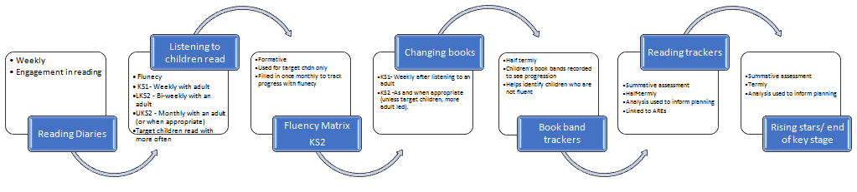

**F**

**Figure 1: Assessment of reading at Kibworth**

1. Summative assessment

During the assessment cycle, Rising Stars and past SATs reading comprehension tests are conducted in Y1-6. Overall termly judgements will be informed by test scores, along with teacher assessment and a wider range of evidence.

Individual trackers will be completed by the class teacher, recording which children are working towards age related expectations and those working above. These assessments will be made half termly. This information can then be relayed to the next year group during handover.

Teachers will also submit a termly half termly ‘best fit’ judgement to the assessment leader. These are used in professional discussion during pupil progress meeting to identify any pupils or groups of pupils who may need to receive targeted support in the following half term. Best fit judgements are then submitted the Trust termly.

Individual progress is also reported back to parents on a termly basis, either through parents’ evenings or a written report.

1. **Phonics assessment**

*EYFS*

In EYFS the children are initially accessed on their phonological awareness during their baseline assessment. These activities include rhyming, alliteration and initial sounds. From their baseline’s children are put into specific phonics groups depending on their needs. Children are assessed regularly after each phase is taught in EYFS.

*KS1*

When children enter Year 1 their final phonic assessment from EYFS is passed on to the teachers. The children begin with a recap of their prior phase and then they are assessed once the new phase has been taught. In Year 1 the phonics assessments of each phase are sent home for parents to help their child at home.

In Year 2 most children are working at phase 5 and 6 with their phonic knowledge secure. Children who are not working at a secure level are regularly assessed within the phase they are working on to check that they are moving forwards with their phonics.

1. **Fluency assessment- See appendix 5**

For children whose fluency is not at the expected level, a fluency matrix (developed by staff) may be used to track their progress on a formative basis. The matrix breaks down fluency into its four components (autonomy, phraseology, expression and volume, pace) so each strand can be monitored when assessing children’s fluency.

**Parental engagement**

Co-operation and support from parents is paramount if a child is to become a successful and competent reader. At Kibworth, we strive to develop and encourage a strong partnership between home and school.

* Reading books are sent home regularly for children to share with parents.
* The weekly reading raffle is used to encourage children and parents to share books are reading diaries at home at least 5 times a week.
* Reading raffle winners published in weekly newsletter.
* Reading mentioned regularly in weekly newsletter.
* Our school website provides current information on reading at Kibworth.
* Reading expectations are provided online and at parents’ evenings.
* Reading discussed in depth at parents’ evening and recommended reads available for parents to take home.
* A monthly reading newsletter is shared with parents to provide recommended reads, messages from authors and top tips for parents and children.

**Appendices Appendix 1- Blank planning proforma**

|  |  |  |  |  |  |
| --- | --- | --- | --- | --- | --- |
|  | Monday | Tuesday | Wednesday | Thursday | Friday |
| Revisit/review |  |  |  |  |  |
| Teach |  |  |  |  |  |
| Practice |  |  |  |  |  |
| Apply |  |  |  |  |  |

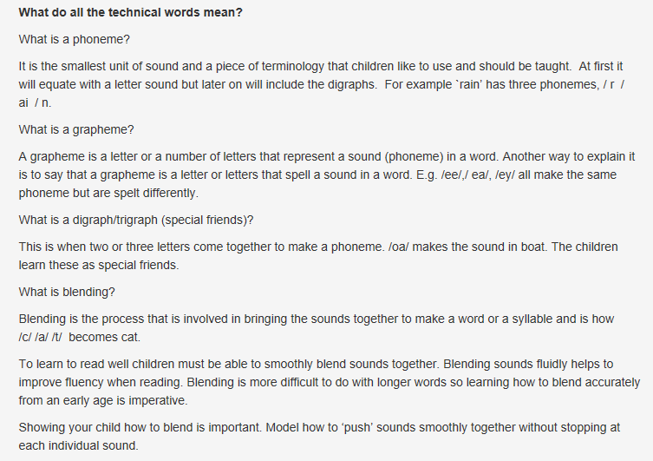**Appendix 2 – Key phonics terminology explained**

**Appendix 3 – Tricky and high frequency words list**

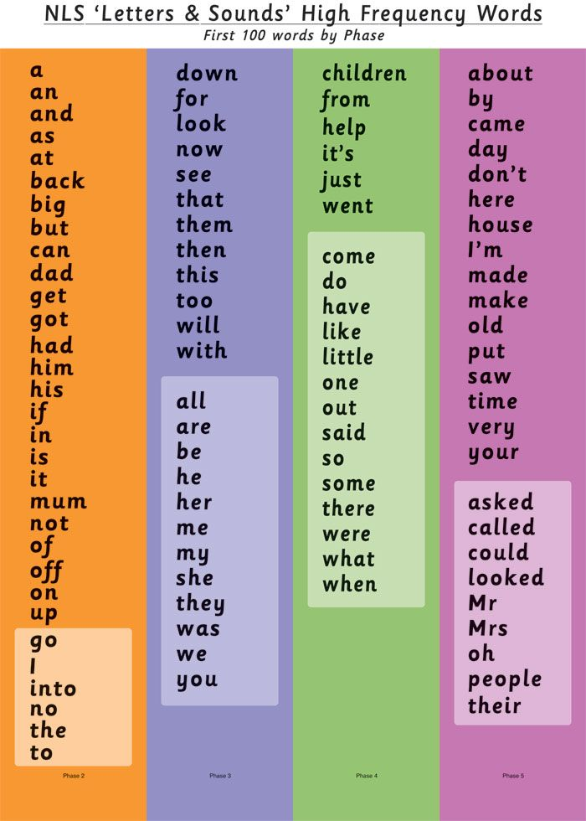

**Appendix 4 - Progression of questioning**

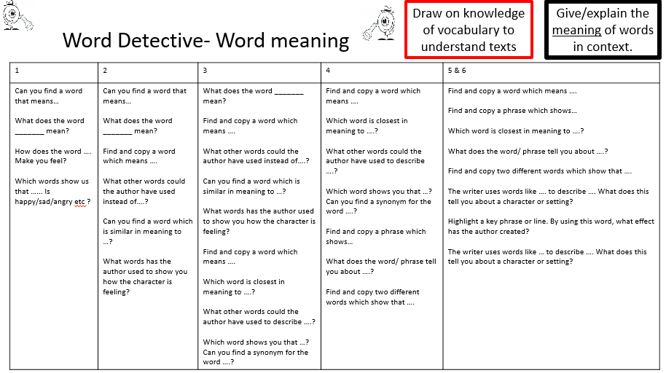

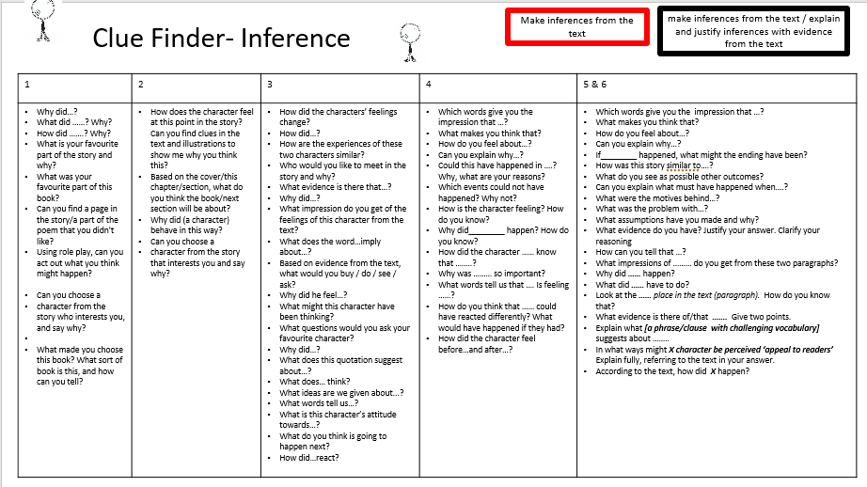

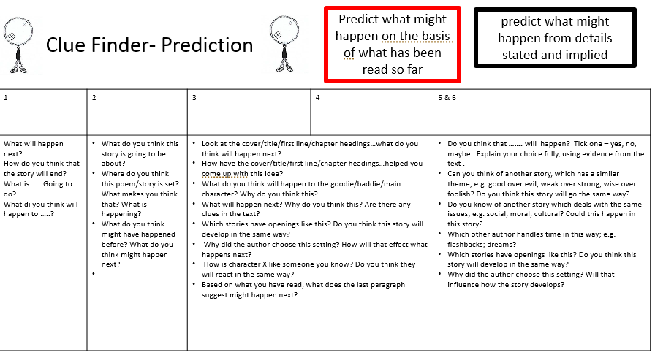

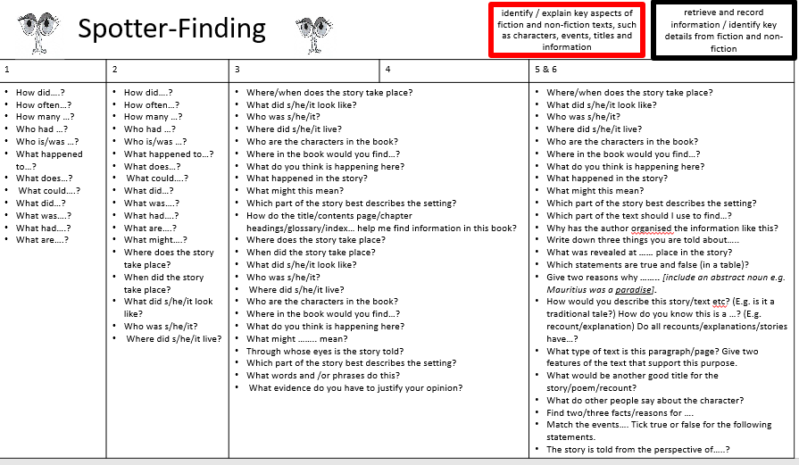

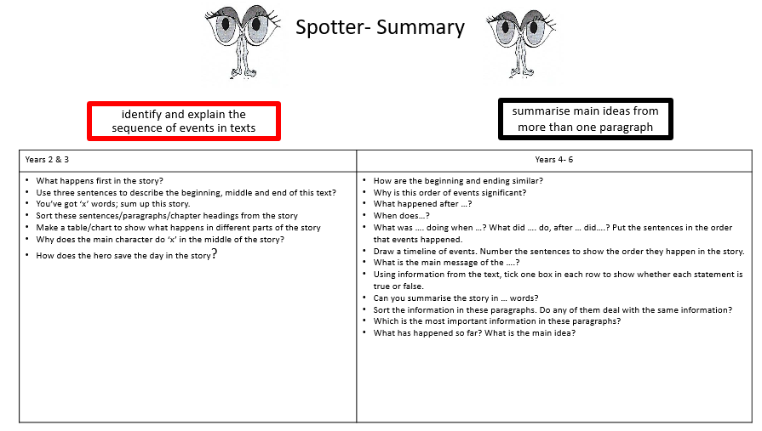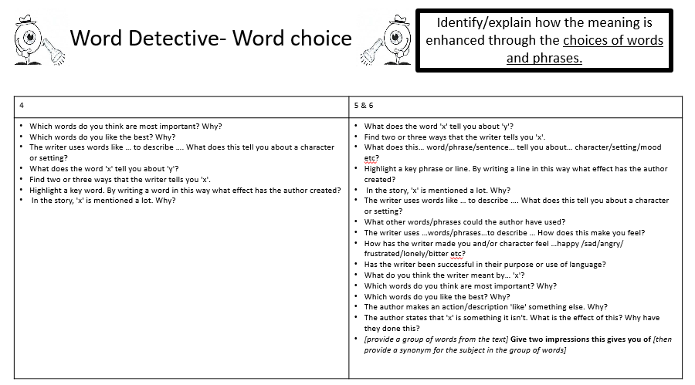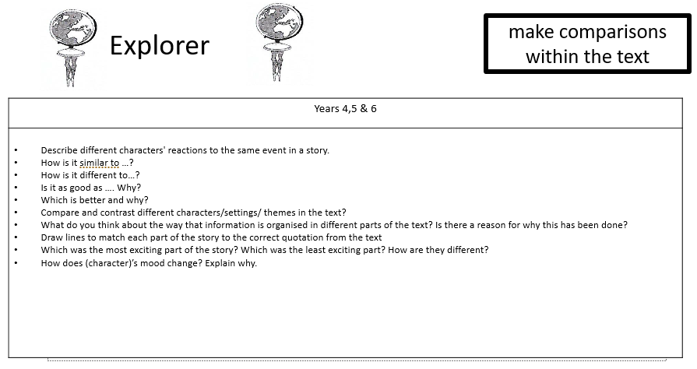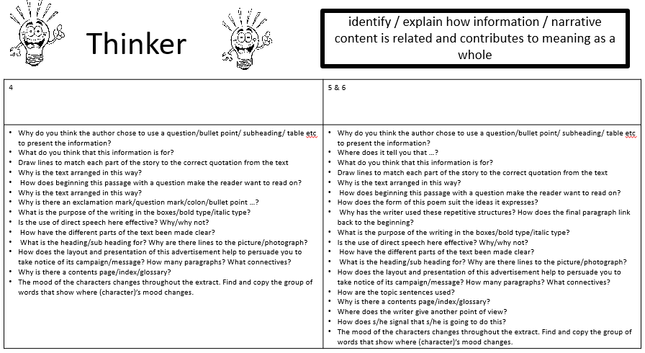

**Appendix 5- Reading fluency matrix**

