

Holds a pencil correctly.

**Writing**

**Progression Map**

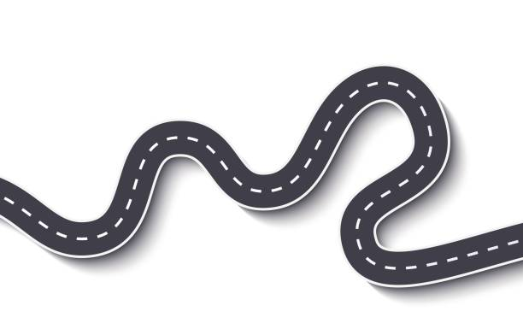

Independently segments the sounds in words to write cvc words.

Hears and writes the initial sounds in words.

Forms lower-case letters correctly.

Forms most letters correctly in pre-cursive, starting every letter on the line.

Begins to make suggestions as to how their work could be improved.

Writes sentences that can be read by themselves and others.

Orally rehearses and writes a simple caption.

Spells all phase 2 and some phase 3 common exception words correctly in their writing.

Writes simple sentences using capital letters, finger spaces and full stops.

Forms capital letters correctly.

Writes some or all of their name.

Has a dominant hand.

Traces letters with good control.

Draws pre-writing shapes.