
Kibworth Primary School
Year 2: Spring 1 Term 2021
Curriculum Information





Explorers!
Dear Parents,

We hope that you had a very happy and peaceful break over Christmas.
We are excited to begin our new topic; ‘Explorers’ and engage with the fantastic novel; ‘George’s Marvellous Medicine’.
Below is an idea of the learning your children will cover this term.

English
Fiction – Narrative
George’s Marvellous Medicine (Roald Dahl)
The children will be using this story to make simple inferences and understand the meaning of new words. We will be using question marks and exclamation marks to punctuate sentences and make our writing more engaging. We will be consolidating the use of capital letters for proper nouns (names, places, months, days of the week) before writing our own version of the chapter ‘Grandma gets the medicine’.

Non-Fiction – Instructions
We will be investigating instructional writing to understand its features. We will then be creating a set of instructions to make our own magical medicines.

Reading
This term we are focusing on using our reading characters to help us to answer questions about George’s Marvellous Medicine and other texts. We will also be working on our speed and fluency when reading more challenging texts. Please make sure you continue to read at home as much as possible.

Word detective: Draw on knowledge of vocabulary to understand texts.
Investigator: Identify/explain key aspects of fiction and non-fiction texts, such as characters, events, titles and information.
Clue Finder PAST: Make inferences from the text.
Clue Finder FUTURE: Predict what might happen on the basis of what has been read so far.
Spotter: Identify and explain the sequence of events in texts.

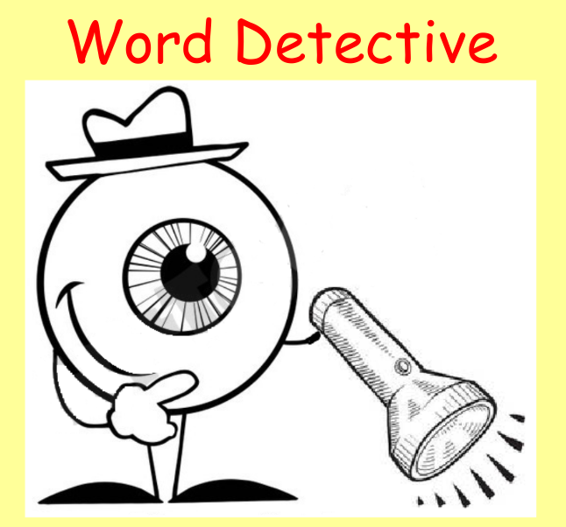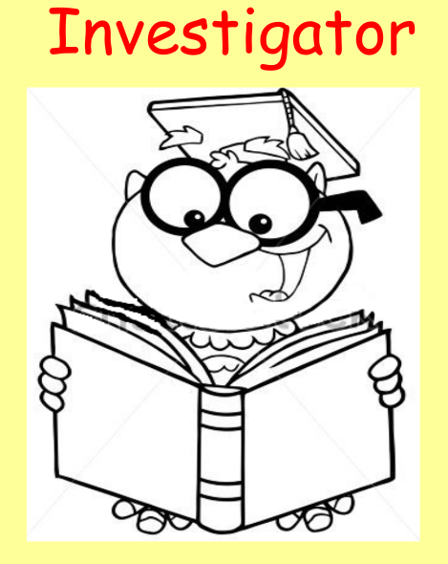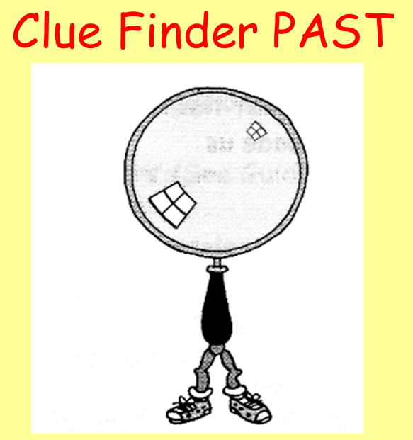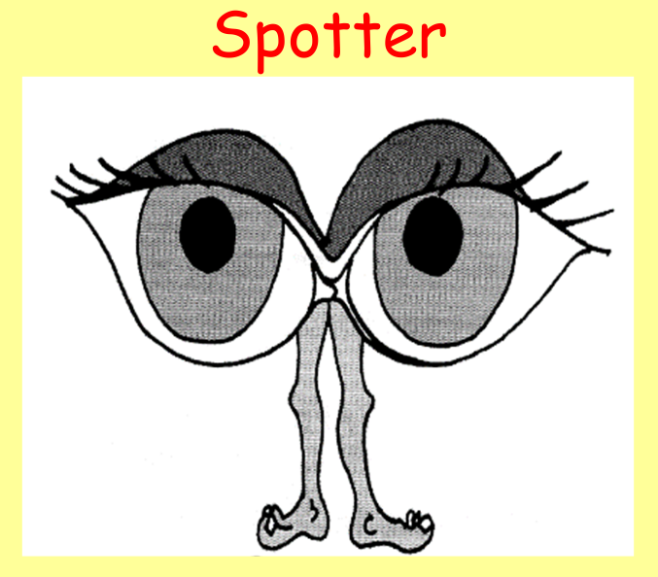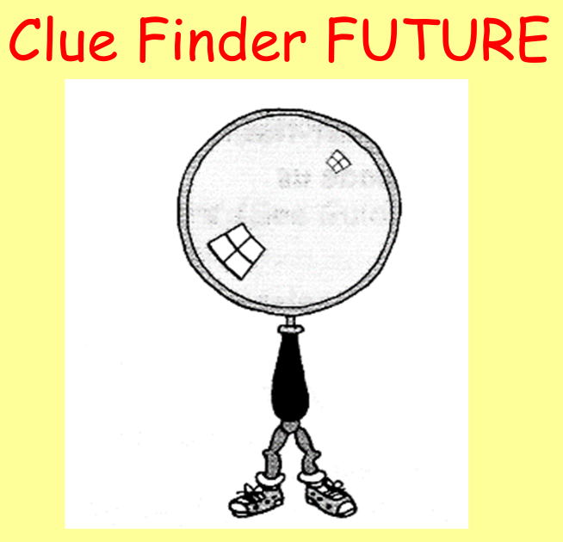
Maths
During this term we will be introducing multiplication and division.
The children will be using the vocabulary; arrays, groups of, lots of and times to understand and solve multiplication problems.
They will be developing their knowledge of the 2, 5 and 10 times tables and learning how to count in threes.
They will look at division through sharing and grouping and how to solve a range of problems using practical resources, pictorial examples and a number line.

At the end of the term we will begin learning about fractions.
We will look at 1/3, 1/4, 1/2, 2/4, 3/4 and know that all parts must be equal parts of the whole. We will find fractions of shapes and amounts.

Topic  Geography | Explorers | In this topic, the children will be finding out about the names of and locate the seven continents of the world as well as the five oceans of the world. On a map of the United Kingdom, they will be locating the four capital cities of England, Wales, Scotland and Northern Ireland.  They will be using their ‘explorers hats’ to research about two specific continents, discovering facts about the location, population, famous landmarks and native animals.
RE | Who is a Muslim and what do they believe? | We will begin exploring the beliefs, routines and traditions that Muslims have and we will compare this to Christianity. This will continue into Spring Term 2.  Before Easter, we will look at what we celebrate and how we celebrate special times. Specifically the children will learn how Christians celebrate Easter and what matters most to them at this time and how Muslims celebrate Eid-al-Fitr and Ramadan.
PE | Games  (Ball skills/  Target practice)  Gymnastics | Children will work on a rotation between ball skills, target practice and team games throughout the year. They will also be exploring movement, strength, direction and flexibility in gymnastics sessions.
Computing | Programming/  Creating  word documents | Throughout the next term, children will work on a rotation to develop their programming and coding skills using ipads and the bee bots (exploring code.org).  They will also work on computers to hone their basic skills by creating posters on a word document.

If you have any questions or concerns, please do not hesitate to contact us.

Miss Morley, Mrs Winston, Miss Mason
Mrs Sharp, Ms Hodgetts, Ms Jones and Mrs Donoghue-Parker
The Year 2 Team

